We are created in God’s image.
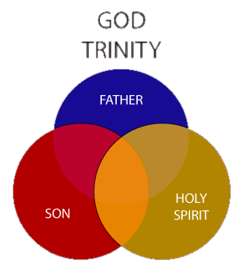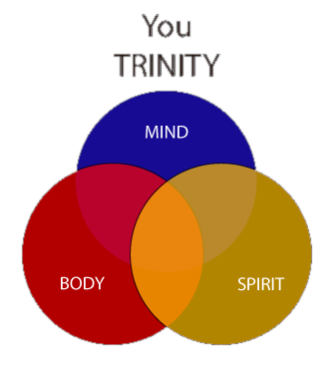
BUT we are born corrupted, with a sin nature. Through Christ, we can receive the Holy Spirit, covering our sin nature. (Our sin is “dead, buried with Christ”.) When God looks at us, he sees his own perfection! We are JUSTIFIED!
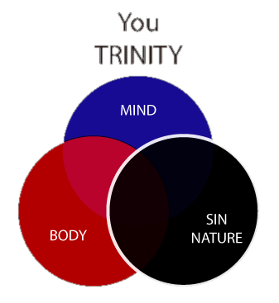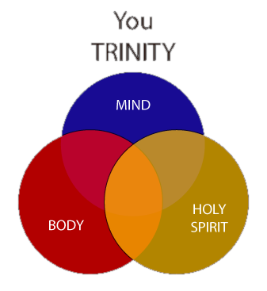

However, our sin nature still exists! We can still sin. Even though it’s dead and buried, we can allow it to come back… SIN ZOMBIE!!! AAAHH!!
What do zombies love? BRAINS! Our sin zombie feeds on our sinful thoughts. The more we allow our minds to dwell on sin, the stronger our sin zombie gets!
As we grow in our faith, we learn to control our thoughts and starve our sin zombie. The stronger our walk with God gets, the weaker our sin zombie gets. Over time, we are SANCTIFIED (which just means “made holy”).

